High Resolution Landcover of Mixed Forests in Northern Wisconsin, USA
FINAL REPORT

Bruce D. Cook

University of Minnesota, Department of Forest Resources
1530 N. Cleveland Ave, St. Paul, MN 55117
Phone: 612-624-9796
E-mail: brucecook@umn.edu

Prepared for: Dr. Steve Manson; GEOG 5565 (Spring 2005)

Submitted: 6 May 2005

ABSTRACT
Multispectral IKONOS imagery was used to create a high-resolution land cover map for an Earth Observing System (EOS) satellite validation study site in northern Wisconsin. Panchromatic texture and raw radiances (NIR, red, green, and blue) were merged to create unique signatures for 12 land classes, which will be used in process-based ecosystem models of forest growth and carbon sequestration. A hierarchical, hybrid of unsupervised and supervised methods was used to classify 4 m pixels within the 10 × 10 km study area, resulting in conservative and optimistic accuracies of 65 and 80%, respectively. Confusions involved species that are found together in mixed stands, and minimum mapping unit differences and positional error between the reference data and classified image were likely sources of error. Landscape coverage for each of the classes was similar to other classifications of the area, and greater resolution revealed small features (e.g., roads, streams, canopy gaps, harvests) and individual classes within mixed stands, which are generalized in larger resolution maps. Variability in lowland area between MODIS-size pixels was large, ranging from <1 to 83%, representing a large source of uncertainty associated with remotely sensed estimates of plant production and carbon exchange between terrestrial ecosystems and the atmosphere.
INTRODUCTION
The objective of this study was to produce a high-resolution land cover map for an Earth Observing System (EOS) satellite validation study site in northern Wisconsin (NASA, 2005a). The landscape at this site is complex and highly fragmented (Bresee et al., 2004), which is typical for much of the Great Lakes Region (Saunders et al., 2002). The ability to accurately estimate standing biomass and monitor vegetation production in this region from remotely sensed satellite imagery (Running et al., 2004) is likely to be limited by: 1) resolution of the Moderate Resolution Imaging Spectroradiometer (MODIS) onboard EOS satellites (approximately 1 km; Barnes et al., 1998); and 2) current algorithms that ignore wetlands (Strahler et al., 1999; Heinsch et al., 2003). To assess these potential errors and improve biomass and production estimates, high-resolution landcover maps are needed to support efforts to upscale ground-based observations using nested ecosystem models (Ahl et al., 2005a; Desai et al., 2005; Davis et al., 2003a; Wang et al., 2004).
Unique spectral characteristics of vegetation types have been used to derive moderate resolution (30 m) land cover maps from multispectral sources for quite some time (e.g., Bolstad and Lillesand, 1992). The Wisconsin DNR commissioned such a map in the 1990s, and a statewide land cover classification, WISCLAND, was produced using multispectral data from Landsat satellites as the primary data source (Wisconsin DNR, 2005a). Spectral signatures for vegetation types vary across the state, and as a result, accuracies vary from region to region.
Ahl et al. (2005a) assessed WISCLAND at the EOS validation site in northern Wisconsin, and found an overall accuracy of 50%. Some of the errors were associated with land use changes (i.e., timber harvesting and forest regrowth) since the 1990s, but confusion between forested and shrub wetland was a widespread problem with the WISCLAND classification.
Overall accuracies were increased to 84% by Ahl et al. (2005a) using higher resolution multispectral data (15 m) collected from an airborne Advanced Thermal and Land Applications Sensor (ATLAS; NASA, 2005b) and a modified classification scheme that aggregated similar deciduous and coniferous species. Unfortunately, the land cover map produced by Ahl et al. only covers an area about 2 × 3 km, and the classification did not separate lowland forests from lowland shrub or wet meadows. Continuous measurements of forest growth and carbon exchange are made from a 400 m AmeriFlux tower at the center of this plot, and “footprints” associated with these measurements extend outwards about 6 km.
The IKONOS satellite is another source of multispectral data that has been utilized for land cover classifications in forested landscapes of the United States and Canada (e.g., Lennertz and Congalton, 2004; Tatham and O’Brian, 2005). IKONOS imagery offers higher resolutions (<1 to 3 m), and a single scene covers an area of about 11 × 11 km. Band widths are rather broad (70 to 130 nm), but canopy shadows (Asner et al., 2003) and texture (Lennertz and Congalton, 2004; Hurtt et al., 2003) can enhance classifications.
Coupling of the IKONOS land cover classification with other sources of remotely sensed data will be explored in future studies. Hyperspectral AVIRIS (Airborne Visible/Infrared Imaging Spectrometer) imagery can be used to reduce confusion between vegetation with similar spectral signatures, and will be used to delineate wetlands to a higher level of accuracy and resolution (15 m) than the existing Wisconsin Wetland Inventory (30 m; Wisconsin DNR, 2005b). Airborne LiDAR (Light Detection and Ranging) measurements will be collected during 2005 to produce highly accurate maps of forest structure (e.g., canopy heights, wood volume; Næsset, 1997). Spacing between laser pulses (1 to 3 points m⁻³) is small enough to isolate individual trees, and fusion with land cover data has been shown to improve biomass inventories (Popescu and Wynne, 2004).

MATERIALS AND METHODS
Site Description
The EOS validation site in northern Wisconsin is located at 90.2729ºN, 45.9451ºW (Figure 1). The site is centered on a 400 m tall broadcasting tower (Figure 2), which is used as a platform for measuring ecosystem-atmosphere exchange of CO₂ and inferring landscape-scale forest growth (Davis et al., 2003b). A 10×10 km area representing the approximate “footprint” of the tower observations was classified for this study. Approximately 71% of total land area is located within the Chequamegon-Nicolet National Forest (CNNF), which is actively managed for recreation, wildlife, preservation, and forestry products, and about one-third is occupied by wetlands. Differences in land ownership, land use, and physical geography contribute to a complex, fragmented pattern of vegetation (Figure 2; Bresee et al., 2004), which is typical of the Great Lakes Region (Saunders et al., 2002)
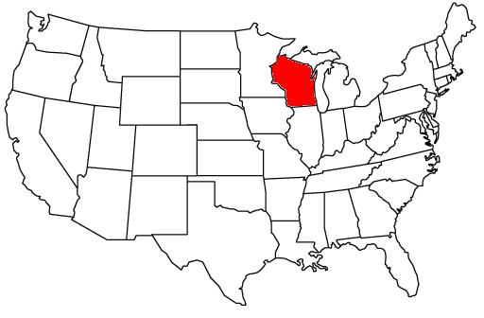
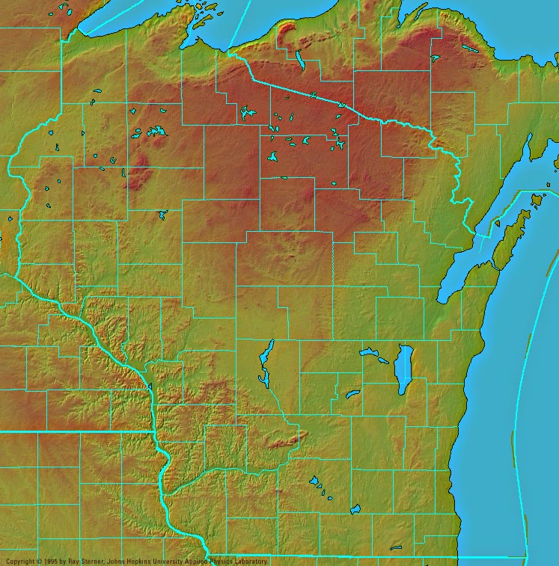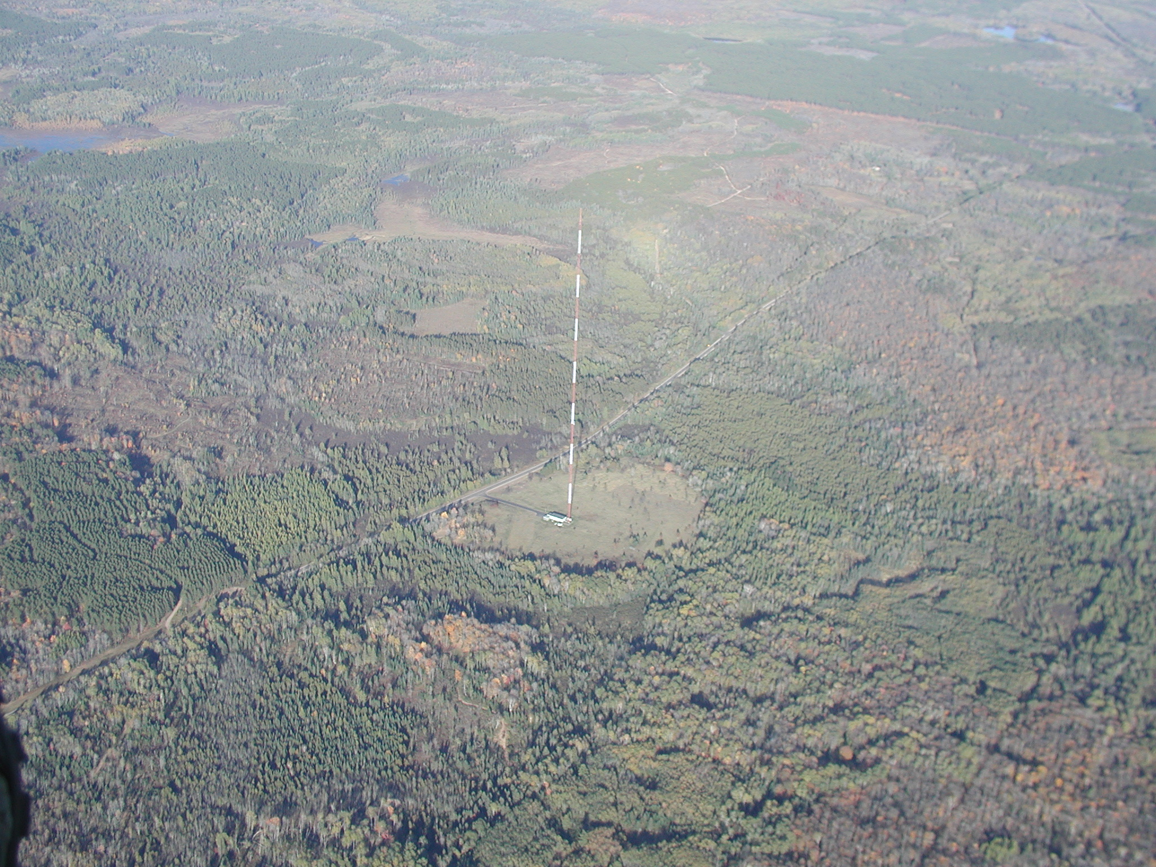

Figure 1. Location of the Earth Observing System Figure 2. Complex landscape of the Chequamegon-
(EOS) core validiation site near Park Falls, WI, USA Nicolet National Forest (CNNF) and adjoining lands
(Color landform map courtesy of Ray Sterner, © 1995). (photo courtesy of Michael L. Jensen, 2003).
IKONOS Imagery
A multispectral image acquired from the IKONOS satellite on 5 July 2002, 1712 GMT, was procured by the National Aeronautics and Space Administration (NASA) John C. Stennis Space Center for this study. Acquisition during mid-growing season and solar noon was an ideal time for characterizing different vegetation spectra and minimizing shadows. The image was geocorrected by Space Imaging (Thorton, CO) to a positional accuracy of <15 m. The panchromatic band has a resolution of 1 m, while the multispectral bands (near infrared, red, green, and blue) have resolutions of 4 m. Relative spectral response and positions of these broad spectral bands are shown in Figure 3.
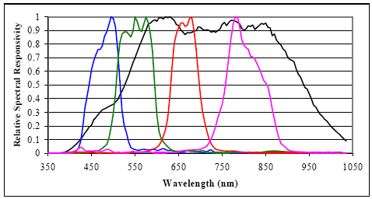
Source: Space Imaging, Thorton, CO
Figure 3. IKONOS Relative spectral response: black, panchromatic band (450 to 900 nm); blue, blue band (450 to 520 nm); green, green band (510 to 600 nm); red, red band (630 to 700 nm); magenta, near infrared band (760 to 850 nm).

Land Cover Classes
Each 4 m IKONOS pixel was assigned to one of the land cover classes listed in Table 1. These categories were chosen on the basis of: 1) distinct spectral and textural patterns that could be identified from remotely sensed data (discussed below); 2) similar processes model parameters (BIOME-BGC; Running and Hunt, 1993), or similar to ecosystems being monitored by the Chequamegon-Ecosystem Atmospheric Study (ChEAS, 1995); and 3) compatibility with EOS global land cover products (International Biosphere-Geosphere Program, IGBP; University of Maryland’s Global Land Cover Classification, UMD). This strategy incorporates quantifiable error into regional estimates of forest growth and carbon exchange, which can be attributed to within class variability (Ahl et al., 2004) and ineffective aggregation of class at different spatial scales (Reich et al., 1999). Quantifying and reducing these errors is an overall objective of upscaling efforts at this site.

Table 1. Land cover classes used for this study, and corresponding categories from other classifications (class values in parentheses) used to select training sites and interpret the unsupervised classification.
_____________________________________________________________________________________________

Site Specific Chequamegon-Nicolet National Forest Wisconsin Wetlands Inventory
_____________________________________________________________________________________________

UPLANDS

Forested
Upland Conifer Red Pine (2) Upland (U)
Jack Pine (1)
White Pine (3)

Aspen-Birch Quaking Aspen (91) Upland (U)
Paper Birch (92)

Upland Hardwood Sugar maple-Basswood (82) Upland (U)
Sugar maple (85)
Mixed hardwoods (89)

Non-Forested
Upland Openings/Shrub Upland Shrub (98) Upland (U)

Grassland Open Upland/Wetland (99) Upland (U)

Road “Roads” polygon Road (ROAD)

LOWLANDS

Forested
Lowland Conifer Lowland Black Spruce (12) Forested Wetland,
Northern White Cedar (14) Needle Leaved (T8)
Tamarack (15)
Mixed Swamp Conifer (18)

Lowland Deciduous Black Ash-American Elm-Red Maple (71) Forested Wetland, Broad
Mixed Lowland Hardwoods (79) Leaved Deciduous (T3)

Non-Forested
Lowland Shrub Lowland Shrub (97) Scrub/Shrub Wetland (S)

Wet Meadow Open Upland/Wetland (99) Emergent/Wet Meadow (E)

Open Water “Lakes” and “Streams” polygons Open Water (W)
_____________________________________________________________________________________________
Training Sites

A vast majority of the study site has been measured and classified by field surveys conducted by the USDA Forest Service, Chequamegon-Nicolet National Forest (CNNF). Stands boundaries have been identified for management purposes, and each site is re-assessed at least once every 10 years. These provided representative sites of known cover, “training sites”, at numerous locations across the site (Figure 4), and increased the likelihood that the full range of soil types, landscape positions, vegetation densities, and age classes were included in the signature for each class. Mixed stands were excluded as training sites (Table 1); “fuzzy signatures” could have been developed for these stands, but detailed information on relative species composition was lacking. Training sites were not identified for roads and streams, since features dimensions were often smaller than image resolution.

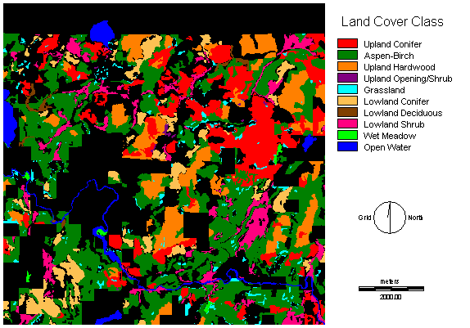
Figure 4. Location of training sites using data from the Chequamegon-Nicolet National Forest (CNNF) and Wisconsin Wetlands Inventory (WWI).

Data from the 1984 Wisconsin Wetlands Inventory (WWI; Wisconsin Department of Natural Resources, 2005a) was used to increase the number of wetland sites (Figure 4), and classifications were cross-validated with CNNF stand data (Table 1). Approximately 16% of the CNNF and WWI classifications did not agree on an upland/wetland designation, and were discarded as training sites. These differences may reflect conflicting wetland definitions and classification objectives, but it also suggests the need for a more accurate and precise wetlands map of the study site. Wetlands appearing in the WWI were classified and delineated using 1:24,000 scale aerial photos, with a minimum mapping unit of only 0.8 to 2.0 ha. The statewide land cover classification, WISCLAND, masked the WWI and did not attempt reevaluate the classifications and positional accuracies of these wetlands.

Image Enhancement and Signature Development

A secondary objective of this study was to evaluate the utility of classification modules in IDRISI Kilimanjaro (Clark Labs, Worcester, MA) for analyzing multispectral IKONOS data. Clark Labs claims to have the fastest classifiers on the market, and they have incorporated several tools for image restoration, transformation, and signature development (Eastman, 2003). In addition to upwelling radiance from the four spectral bands (Figure 5b), the potential for using signatures derived from transformed bands and panchromatic texture to classify land cover across the entire scene was evaluated.
Transformation of raw spectral radiances is often used to reduce inter-band correlations and enhance spectral differences between land cover features. The “tasseled cap” transformation was introduced by Kauth and Thomas (1976) as a method for monitoring agricultural crops, but the first two components (brightness and greenness) contain valuable information relating to soil reflectance and vegetation greenness. The four Landsat Multispectral Scanner (MSS) bands used in the tasseled cap transformation are analogous to the four IKONOS bands, and it is relatively easy to adopt this linear transformation as an alternative to spectral signatures from raw bands (Figure 5c).

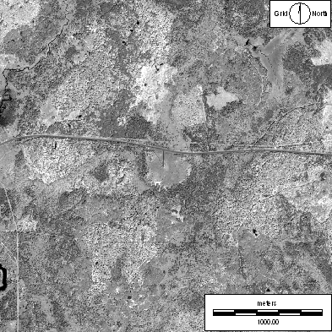  Tower  Paved Highway  a) High resolution panchromatic band. | 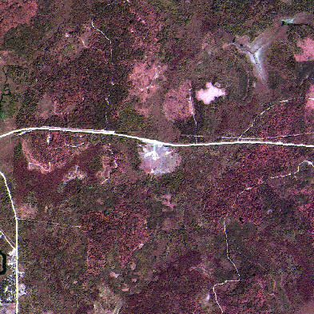  Stream////  Gravel Road  Harvested uplands  b) True color image using red, green, blue (RGB) bands.
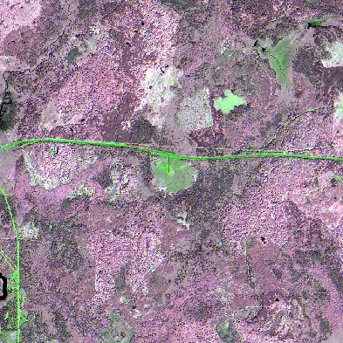  Wet Meadows  Lowland Conifer  Grassland  c) False color image using tasseled cap brightness, greenness, and yellowness as RGB bands. | 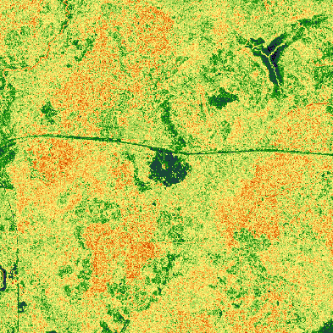  Upland hardwood  (red)  Lowland Shrub  (dark green)  Aspen  Red Pine  (light green)  (green)  d) Panchromatic texture (see text for details).

Figure 5a-d. Appearance of site specific land cover features in IKONOS-derived images for a 3 × 3 km area around the tall tower on 5 July 2002.

Spatial pattern recognition, i.e., comparing a raster cell to neighboring pixels, is an alternative to spectrally oriented classification, and the analysis takes full advantage of high resolution IKONOS data. For this study, texture was calculated for each 1 m panchromatic pixel (Figure 5a) using a 7 × 7 kernel and relative richness index, after which, the image was contracted to 4 m resolution by pixel aggregation (Figure 5d).
Linear contrast stretching and compositing was used to enhance the appearance and accentuate differences between site specific features, as illustrated in Figure 5. Principal component analysis (PCA) of the entire scene was used during preprocessing to identify meaningful underlying information from the IKONOS imagery, and the results of these analyses are presented in Table 2. Correlation within visible (IKONOS red, green, and blue) and tasseled cap transformed bands (brightness, greenness, yellowness, and nosuch) was high (r>0.82), while raw NIR was highly correlated with greenness (r=0.996) and panchromatic pattern was poorly correlated (r<0.20) with all of the spectral bands. Eigenvectors indicated that most of the variability (99.6%) was captured in the first three components, and loadings revealed that NIR, texture, and raw visible bands exhibited the strongest influence on these components.

Table 2. Principal Component Analysis of raw IKONOS bands (NIR, red, green, blue), tasseled cap transformed bands (brightness, greenness, yellowness, nosuch); and panchromatic texture for the entire scene.

a) Correlations.

 | NIR | Red | Green | Blue | Brightness | Greenness | Yellowness | Nosuch | Pattern
NIR | 1.000 | 0.302 | 0.491 | 0.147 | 0.855 | 0.996 | 0.987 | 0.987 | 0.181
Red |  | 1.000 | 0.905 | 0.882 | 0.739 | 0.291 | 0.304 | 0.223 | -0.190
Green |  |  | 1.000 | 0.825 | 0.858 | 0.452 | 0.521 | 0.426 | -0.113
Blue |  |  |  | 1.000 | 0.601 | 0.115 | 0.107 | 0.080 | -0.226
Brightness |  |  |  |  | 1.000 | 0.837 | 0.851 | 0.811 | 0.024
Greenness |  |  |  |  |  | 1.000 | 0.979 | 0.993 | 0.184
Yellowness |  |  |  |  |  |  | 1.000 | 0.982 | 0.187
Nosuch |  |  |  |  |  |  |  | 1.000 | 0.201
Texture |  |  |  |  |  |  |  |  | 1.000
b) Eigenvectors (% of variance).
Component | C1 | C2 | C3 | C4 | C5 | C6 | C7 | C8 | C9
Variance (%) | 73.82 | 24.74 | 1.01 | 0.20 | 0.11 | 0.06 | 0.03 | 0.02 | 0.00
c) Loadings.
 | C1 | C2 | C3 | C4 | C5 | C6 | C7 | C8 | C9
NIR | 0.993 | -0.106 | -0.010 | -0.028 | 0.061 | -0.023 | -0.001 | 0.001 | -0.001
Red | 0.242 | -0.245 | 0.892 | -0.008 | 0.019 | 0.073 | -0.191 | -0.055 | -0.019
Green | 0.444 | -0.247 | 0.810 | -0.013 | 0.031 | 0.061 | 0.192 | -0.050 | -0.018
Blue | 0.101 | -0.226 | 0.877 | -0.004 | 0.010 | 0.075 | 0.000 | 0.375 | -0.018
Brightness | 0.832 | -0.210 | 0.488 | -0.024 | 0.053 | 0.024 | 0.000 | 0.000 | 0.041
Greenness | 0.995 | -0.102 | 0.029 | -0.028 | -0.043 | -0.020 | 0.000 | 0.000 | 0.000
Yellowness | 0.983 | -0.100 | 0.028 | 0.152 | 0.000 | -0.019 | 0.000 | 0.000 | 0.000
Nosuch | 0.993 | -0.084 | -0.055 | 0.000 | 0.000 | 0.038 | 0.000 | 0.000 | 0.000
Texture | 0.284 | 0.959 | 0.010 | 0.010 | -0.000 | 0.001 | -0.000 | 0.000 | 0.000
Classification Methodology and Smoothing
A hierarchical, hybrid image classification technique was used to classify the IKONOS imagery. “Hierarchical” refers to the classification of wetlands and uplands separately, and “hybrid” refers to the use of both unsupervised and supervised methods of automated classification.
Spectral signatures of vegetation can be similar enough to confuse upland and wetland types, and it can be assumed that overall accuracy will be improved by analyzing spectral signatures separately. As has been done for other classifications (e.g., Ahl et al., 2005a; Wisconsin Department of Natural Resources, 2005b), IKONOS pixels were initially separated into upland or wetland categories. For each of these groups, pixels were broadly generalized into similar clusters using unsupervised classification. Each of the clusters was evaluated to determine identity (Figure 5); clusters that represented similar land cover (Table 1) were combined, and heterogeneous clusters were further separated by supervised, maximum likelihood classification using signatures developed from the raw IKONOS bands and panchromatic texture (see above). Unsupervised classification with retention of all clusters resulted in 13 lowland clusters and 11 uplands clusters. Supervised classification was performed on 55% of upland pixels, and 21% of lowland pixels.
Follow the pixel-by-pixel classification, a 3 × 3 majority filter was applied to the data. This reduced the roughness of the classification imagery that was associated with shadows and sensor noise.

RESULTS AND DISCUSSION

Classification Map

The classification map (Figure 6) adequately preserved all of the site specific land cover features indicated in the raw images (Figure 5). From a landscape perspective, the site map closely resembled the CNNF stand classifications (Figure 4), and to lesser extent, WISCLAND (Figure 7). Ahl et al. (2005a) observed that WISCLAND accuracy is somewhat poor (50%) in this part of the state; ground-truth observations revealed that many lowland forests were misclassified as lowland shrub, and many of aspen stands were misclassified as upland hardwood. These same biases were reflected in the IKONOS classification (Figure 7).
An advantage of the high-resolution IKONOS classification is the elimination of the mixed forest class (Figure 7). This will allow future studies to determine whether mixed forests can be scaled by summing model estimates for the individual components. The IKONOS imagery has the ability to sense the forest canopy and gaps between individual and small groups of trees, which is desired for fusion with other high resolution data (e.g., LiDAR). The ability to detect and quantify forest openings and canopy gaps differs from classifications using moderate-resolution data (e.g., Landsat), which tend to generalize more and incorporate percent cover into class descriptions. Disadvantages of using high resolution IKONOS imagery for land cover classification include fewer spectral bands and a higher potential for confusion due to shadows and understory vegetation.

Figure 6. IKONOS classification for comparison with 3 × 3 km feature images above.

a) IKONOS. | b) WISCLAND. | c) MODIS-UMD and IGBP.
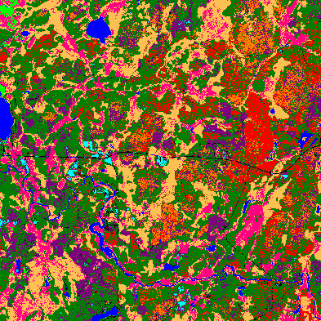 | 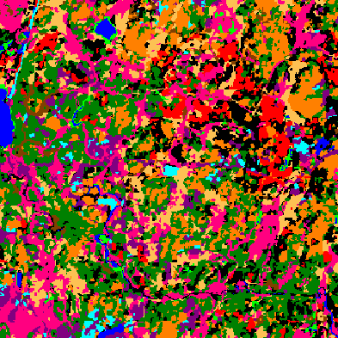 | 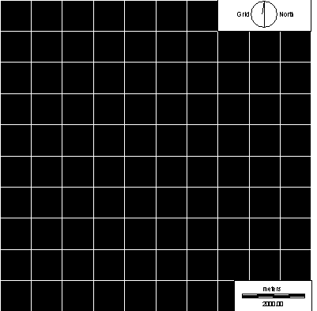
. Mixed Forest  13.3% Upland Conifer  34.8% Aspen-Birch  5.7% Upland Hardwood  12.0% Upland Opening/Shrub  0.9% Grassland  17.8% Lowland Conifer  0.7% Lowland Deciduous  10.6% Lowland Shrub  0.6% Wet Meadow  2.6% Open Water  1.0% Road | 7.1% Mixed Forest  13.0% Upland Conifer  25.3% Aspen-Birch  14.6% Upland Hardwood  6.8% Upland Opening/Shrub  1.8% Grassland  10.7% Lowland Conifer  1.9% Lowland Deciduous  16.3% Lowland Shrub  1.0% Wet Meadow  1.6% Open Water  . Road | 100% Mixed Forest

Figure 7a-c. Comparison of a) IKONOS; b) WISCLAND; and c) MODIS land cover products for the entire study site (refer to Fig. 6 legend, adding black for Mixed Forest).

Accuracy Assessment
The high-resolution map described in this paper was not prepared for the purpose of delineating stands, but to provide detailed information on the composition and spatial variability of discrete land cover features. This complicates traditional methods of assessing classification accuracy, i.e., assembling an error matrix and computing a kappa coefficient, due to the potential for positional errors and discrepancies between pixel and field plot sizes (Verbyla and Hammond, 1995). A conservative estimate of classification accuracy was determined by a pixel-to-pixel comparison of the IKONOS classification and a systematically arrangement of 180 field sites around the tall tower (Burrows et al., 2002). A 7 × 7 majority filter was applied to the IKONOS data to approximate the size of the field plots. This method produced an overall accuracy of 65% and a Kappa coefficient of 0.56 (Table 3). A more optimistic estimate of classification accuracy was obtained by excluding sites with heterogeneous blocks of pixels (Hammond and Verbyla, 1996). An overall accuracy of 80% was achieved using sites with <3 land cover class in a 7 × 7 window (n=49). Most of the confusions involved species that are found together in mixed stands, and a visual inspection of the images suggested that minimum mapping unit differences and positional error between the reference data and classified image were likely source of error. Accuracy of the ground-based observations was ±50 cm from a local benchmark (Burrows et al., 2002); however, accuracy of the geocorrected IKONOS image was <15 m, and was not expected to be constant across the scene. Verbyla and Hammond (1995) demonstrated that overall accuracies of identical, high-resolution classifications derived from the SPOT satellite (Système Pour l’Observation d la Terre) could be reduced to 77% simply by shifting the image by one pixel.

Table 3. Conservative estimates of classification accuracy using a pixel-by-pixel comparison of 1999-2000 ground-based observations and the IKONOS land cover classification. Lowland Deciduous, Wet Meadow, Open Water, and Road were not sampled in the reference data but appeared in the classification.

Classification | Upland Conifer | Aspen-Birch | Upland Hardwood | Upland Opening/Shrub | Grassland | Lowland Conifer | Lowland Deciduous | Lowland Shrub | Wet Meadow | Open Water | Road | User Accuracy
Upland Conifer | 5 | 1 | 5 | 0 | 0 | 0 | 0 | 0 | 0 | 0 | 0 | 45%
Aspen-Birch | 12 | 48 | 10 | 0 | 0 | 0 | 0 | 0 | 0 | 0 | 0 | 69%
Upland Hardwood | 0 | 0 | 20 | 0 | 0 | 0 | 0 | 0 | 0 | 0 | 0 | 100%
Upland Opening/Shrub | 0 | 2 | 14 | 1 | 0 | 0 | 0 | 0 | 0 | 0 | 0 | 6%
Grassland | 0 | 0 | 0 | 0 | 3 | 0 | 0 | 0 | 0 | 0 | 0 | 100%
Lowland Conifer | 0 | 0 | 0 | 0 | 0 | 26 | 0 | 17 | 0 | 0 | 0 | 60%
Lowland Deciduous | 0 | 0 | 0 | 0 | 0 | 0 | 0 | 0 | 0 | 0 | 0 | ---
Lowland Shrub | 0 | 0 | 0 | 0 | 0 | 0 | 0 | 14 | 1 | 0 | 0 | 93%
Wet Meadow | 0 | 0 | 0 | 0 | 0 | 0 | 0 | 0 | 0 | 0 | 0 | 0%
Open Water | 0 | 0 | 0 | 0 | 1 | 0 | 0 | 0 | 0 | 0 | 0 | ---
Road | 0 | 0 | 0 | 0 | 0 | 0 | 0 | 0 | 0 | 0 | 0 | ---
Producer Accuracy | 29% | 94% | 41% | 100% | 75% | 100% | --- | 45% | 0% | --- | ---

Overall Accuracy: 65%

Kappa Statistic: 0.56
Spatial Aggregation and Variability between MODIS Pixels

Estimates of vegetation production by MODIS algorithms include errors associated with state variables (e.g., land cover, leaf area), parameterization (e.g., light and temperature response functions), and model logic (e.g., the model makes no distinction between uplands and wetlands). Ground-based observations have been used to validate the accuracy of MODIS-based products and estimates of vegetation production (Myneni et al., 2002; Burrows et al., 2002; Ahl et al., 2005a,b; Mackay et al., 2002; Cohen et al., 2003; Turner et al., 2003; Heinsch et al., 2005), but there have been few attempts to evaluate sub-pixel errors and land cover generalizations that may reconcile differences (e.g., Myneni, 2002; Ahl et al., 2005a; Mackay et al., 2002). The EOS validation site in northern Wisconsin is well suited for this type of study, because the landscape is complex and fragmented within a 1 km MODIS pixel.
Wetlands occupy about one-third of the landscape in this region (Wisconsin DNR, 2005a), detection of pure pixels at 1 km resolution would be evasive due to their patchy, non-contiguous distribution (Figure 4b). Plant growth and ecosystem processes in wetlands are distinctly different from uplands (e.g., Griffis et al., 2000); however, there is no attempt to identify wetlands in the MODIS land cover algorithm (Strahler et al., 1999), nor are they modeled differently from uplands by the vegetation production algorithm (Heinsch et al., 2003).
MODIS regards the rich mosaic of uplands, wetlands, grassy openings, and small lakes and rivers of the northern Wisconsin study entirely as “Mixed Forest” (Figure 7). A 1 km grid was used to aggregate the high-resolution IKONOS classification into MODIS-size pixels, and the frequency distribution for each class was used to graphically display variability between cells (Figure 8). Distributions of most classes were leptokurtic around a land cover mean of 0 to 10%, indicating that pixel-to-pixel differences were constrained. In contrast, Aspen-Birch and Lowland Conifer distributions exhibited platykurtic shapes over a broad range of cover. These classes dominated the upland and wetland sites (Figure 7), and their overlapping distributions reflected a wide range of wetland area (<1 to 83% of total land area) between simulated MODIS pixels.
Figure 8. Frequency distributions between MODIS-size pixels (n=100; bin size=10).

CONCLUSION

An accurate, high-resolution land cover map was prepared for the EOS validation site in northern Wisconsin, USA, using images from the IKONOS satellite. Twelve land cover classes were chosen to support ecosystem process models, and a 10 × 10 km scene was classified using a hybrid of supervised and unsupervised methods. Spectral signatures were enhanced using an index of texture from the panchromatic band, resulting in conservative and optimistic accuracies of 65 and 80%, respectively. Landscape coverage for each of the classes was similar to other classifications of the area, and greater resolution revealed small features (e.g., roads, streams, canopy gaps, harvests) and individual classes within mixed stands, which are generalized in larger resolution maps. Variability in lowland area between MODIS-size pixels was large, ranging from <1 to 83%, representing a large source of uncertainty associated with remotely sensed estimates of plant production and carbon exchange between terrestrial ecosystems and the atmosphere.

CITATIONS
Ahl, D. E., S. T. Gower, D. S. Mackay, S. N. Burrows, J. M. Norman, and G. R. Diak. 2004. Heterogeneity of light use efficiency in a northern Wisconsin forest: Implications for modeling net primary production with remote sensing. Remote Sensing of Environment 93:168-178.
Ahl, D. E., S. T. Gower, D. S. Mackay, S. N. Burrows, J. M. Norman, and G. R. Diak. 2005a. The effects of aggregated land cover data on estimating NPP in northern Wisconsin. Remote Sensing of Environment (in press).
Ahl, D. E., S. T. Gower, and S. N. Burrows. 2005b. Monitoring spring canopy phenology of a deciduous broadleaf forest using MODIS. Remote Sensing of Environment (submitted).
Asner, G. P., and A. S. Warner. 2003. Canopy shadow in IKONOS satellite observations of tropical forests and savannas. Remote Sensing of Environment 87:521-533.
Barnes, W. L., T. S. Pagano, and V. V. Salomonson. 1998. Prelaunch characteristics of the Moderate Resolution Imaging Spectroradiometer (MODIS) on EOS-AM1. IEEE Transactions on Geoscience and Remote Sensing, 36:1088-1100.
Bolstad, P. V., and T. M. Lillesand. 1992. Improved classification of forest vegetation in northern Wisconsin through a rule-based combination of soils, terrain, and Landsat Thematic Mapper data. Forest Science 38:5-20.
Bresee, M. K., J. Le Moine, S. Mather, K.D. Brosofske, J. Chen, T. R. Crow, and J. Rademacher. 2004. Disturbance and landscape dynamics in the Chequamegon National Forest Wisconsin, USA, from 1972 to 2001. Landscape Ecology 19:291-309.
Burrows, S. N., S. T. Gower, M. K. Clayton, D. S. Mackay, D. E. Ahl, J. M. Norman, and G. Diak. 2002. Application of geostatistics to characterize leaf area index (LAI) from flux tower to landscape scales using a cyclic sampling design. Ecosystems 5:667-679.
Chequamegon Ecosystem-Atmospheric Study. 2005. Revised 2 April 2003. ChEAS Home Page. <http://cheas.psu.edu> Accessed 1 May 2005.
Cohen, W.B., T.K. Maiersperger, Z. Yang, S.T. Gower, D.P. Turner, W.D. Ritts, M. Berterretche, and S.W. Running. 2003. Comparisons of land cover and LAI estimates derived from ETM+ and MODIS for four sites in North America: a quality assessment of 2000/2001 provisional MODIS products. Remote Sensing of Environment 88:221-362.
Davis, K. J., D. R. Ricciuto, M. P. Butler, A. R. Desai, W. Wang, C. Yi, P. S. Bakwin, B. D. Cook, P. V. Bolstad, E. Carey, J. Martin, R. Teclaw, D. S. Mackay, B. E. Ewers, J. Chen, A. Noormets, F. A. Heinsch, and A. S. Denning. 2003a. A challenge to the flux-tower upscaling hypothesis? A multi-tower comparison from the Chequamegon Ecosystem-Atmosphere Study. Eos Trans. AGU, 84(46), Fall Meet. Suppl., Abstract B42D-07.
Davis, K. J., P. S. Bakwin, C. Yi, B. W. Berger, C. Zhao, R. M. Teclaw, and J. G. Isebrands. 2003b. The Annual cycles of CO₂ and H₂O exchange over a northern mixed forest as observed from a very tall tower. Global Change Biology 9:1278-1293.
Desai, A. R., A. Noormets, P. V. Bolstad, J. Chen, B. D. Cook, K. J. Davis, E. S. Euskirchen, C. Gough, J. M. Martin, D. M. Ricciuto, H. P. Schmid, J. Tang, and W. Wang. 2005. Influence of vegetation type, stand age and climate on carbon dioxide fluxes across the Upper Midwest, USA: Implications for regional scaling of carbon flux. Agricultural and Forest Meteorology (submitted).
Eastman, J. R. 2003. IDRISI Kilimanjaro Guide to GIS and Image Processing. Clark Labs, Worcester, MA.
Griffis, T. J., W. R. Rouse, and J. M. Waddington. 2000. Scaling Net Ecosystem CO₂ Exchange from the Community to Landscape-Level at a Subarctic Sedge Fen. Global Change Biology 6:459-473.
Hammond, T. O., and D. L. Verbyla. 1996. Optomistic bias in classification accuracy assessment. Internation Journal of Remote Sensing 6:1261-1266.
Heinsch, F. A., M. Zhao, S. W. Running, J. S. Kimball, R. R. Nemani, K. J. Davis, P. V. Bolstad, B. D. Cook, A. R. Desai, D. M. Ricciuto, B. E. Law, W. C. Oechel, H. Kwon, H. Luo, S. C. Wofsy, A. L. Dunn, J. W. Munger, D. D. Baldocchi, L. Xu, D. Y. Hollinger, A. D. Richardson, P. C. Stoy, M. B. S. Siqueria, R. K. Monson, S. Burns, L. B. Flanagan. 2005. Evaluation of remote sensing based terrestrial productivity from MODIS using regional tower eddy flux network observations. Remote Sensing of Environment (accepted).
Heinsch, F. A., M. Reeves, P. Votava, S. Kang, C. Milesi, M. Zhao, J. Glassy, W. M. Jolly, R. Loehman, C. F. Bowker, J. S. Kimball, R. R. Nemani, and S. W. Running. 2003. Revised 2 December 2003. User’s Guide: NASA MODIS Land Algorithm, GPP and NPP (MOD17A2/A3) Products, Version 2.0. <http://www.ntsg.umt.edu/modis/MOD17UsersGuide.pdf> Accessed 14 April 2005.
Hurtt, G., X. Xiao, M. Keller, M. Palace, G. P. Asner, R. Braswell, E. S. Brondizio, M. Cardoso, C. J. R. Carvalho, M. G. Fearon, L. Guild, S. Hagen, S. Hetrick, B. Moore III, C. Nobre, J. M. Read, T. Sá, A. Schloss, G. Vourlitis, A. J. Wickel. 2003. IKONOS Imagery for the Large Scale Biosphere-Atmosphere Experiment in Amazonia (LBA). Remote Sensing of Environment 88:111-127.
Kauth, R. J, and G. S. Thomas. 1976. The tasseled cap: A graphic description of the spectral-temporal development of agricultural development of agricultural crops as seen by Landsat. Proceedings of the 2nd International Symposium on Machine Processing of Remotely Sensed Data, Purdue Univeristy, West Lafayette, IN, 1976.
Lennartz, S. P., and R. G. Congalton. 2004 Classifying and mapping forest cover types using IKONOS imagery in the northeastern United States. Proceedings of the Annual Meeting of the American Society of Photogrammetry and Remote Sensing, Denver, CO, 23-28 May 2004.
Mackay, D.S., D.E. Ahl, B.E. Ewers, S.T. Gower, S.N. Burrows, S. Samanta and K.J. Davis. 2002. Effects of aggregated classifications of forest composition on estimates of evapotranspiration in a northern Wisconsin forest. Global Change Biology, 8, 1253-1266.
Myneni, R. B., S. Hoffman, Y. Knyazikhin, J. L. Privette, J. Glassy, Y. Tian, Y. Wang, X. Song, Y. Zhang, G. R. Smith, A. Lotsch, M. Friedl, J. T. Morisette, P. Votava, R. R. Nemani, S. W. Running. 2002. Global products of vegetation leaf area and fraction absorbed PAR from year one of MODIS data. Remote Sensing of Environment 83:214-231.
Næsset, E. 1997. Estimating timber volume of forest stands using airborne laser scanner data. Remote Sensing of Environment 61:246-253.
National Aeronautics and Space Administration (NASA). 2005a. Revised 7 April 2005. EOS Land Validation Home Page. <http://landval.gsfc.nasa.gov/MODIS> Accessed 14 April 2005.
National Aeronautics and Space Administration (NASA). 2005b. Revised 13 October 1999. ATLAS Remote Sensing System. <http://www.ghcc.msfc.nasa.gov/precisionag/atlasremote.html> Accessed 15 April 2005.
Popescu, S. C., and R. H. Wynne. 2004. See the trees in the forest: Using lidar and multispectral data fusion with local filtering and variable window size for estimating tree height. Photogrammetric Engineering and Remote Sensing 70:589-604.
Reich, P. B., Turner, D. P., and P. Bolstad. 1999. An approach to spatially distributed modeling of net primary production (NPP) at the landscape scale and its application in validation of EOS NPP products. Remote Sensing of Environment 70:69-81.
Running, S. W., R. R. Nemani, F. A. Heinsch, M. Zhao, M. Reeves, and H. Hashimoto. 2004. A Continuous satellite-derived measure of global terrestrial primary production. BioScience 54:547-560.
Saunders, S.C., M. R. Mislivets, J. Chen, and D.T. Cleland. 2002. Effects of roads on landscape structure within nested ecological units of the Northern Great Lakes Region, USA. Biological Conservation 103: 209-225.
Strahler, A., D. Muchoney, J. Borak, M. Friedl, S. Gopal, E. Lambin, and A. Moody. 1999. Revised 1 May 1999. MODIS Land Cover Product: Algorithm Theoretic Basis Document (ATBD), Version 5. <http://modis.gsfc.nasa.gov/data/atbd/atbd_mod12.pdf> Accessed 14 April 2005.
Tatham, B., and D. O’Brien. 2001. British Columbia Institute of Technology GIS Student Project: Bringing raster GIS to the District of North Vancouver. <http://giswww1.bcit.ca/giscentre/projects/projects2001/DarrenBert.pdf > Accessed 14 April 2005.
Turner, D.P., W.D. Ritts, W.B. Cohen, S.T. Gower, M. Zhao, S.W. Running S.C. Wofsy, S. Urbanski, A. Dunn, and J.W. Munger. 2003. Scaling gross primary production (GPP) over boreal and deciduous forest landscapes in support of MODIS GPP product validation. Remote Sensing of Environment 88:256-270.
Verbyla, D. L., T. O. Hammond. 1995. Conservative bias in classification accuracy assessment due to pixel-by-pixel comparison of classified images with reference grids. International Journal of Remote Sensing 16:581-587.
Wang, W., K. J. Davis, D. M. Ricciuto, M. P. Butler, B. D. Cook. 2004. Decomposing NEE measured over a mixed forest area and upscaling in northern WI using footprint models and a vegetation map. Eos Trans. AGU, 85(47), Fall Meet. Suppl., Abstract B51A-0933.
Wisconsin Department of Natural Resources. 2005a. Revised 19 February 2005. Wisconsin Wetlands. <http://www.dnr.state.wi.us/org/water/fhp/wetlands/mapping.shtml> Accessed 14 April 2005.
Wisconsin Department of Natural Resources. 2005b. Revised 12 May 2004. Land Cover Data (WISCLAND). <http://www.dnr.state.wi.us/maps/gis/datalandcover.html> Accessed 14 April 2005.

