**US-Los: Lost Creek Plot Diagrams, Explanations**

The Lost Creek plot contains four subplots across three different gradients of moisture. Subplot A is the forested/dry site and measures 20m x 20m. Subplot C (there is no subplot B) is right around the tower, measuring in at a 10m radius and has a minimal amount of standing water on it. Subplot D and E are both in the river and both measure 10m radius. Subplot D is a flowing part of the river and subplot E is a stagnant part of the river.

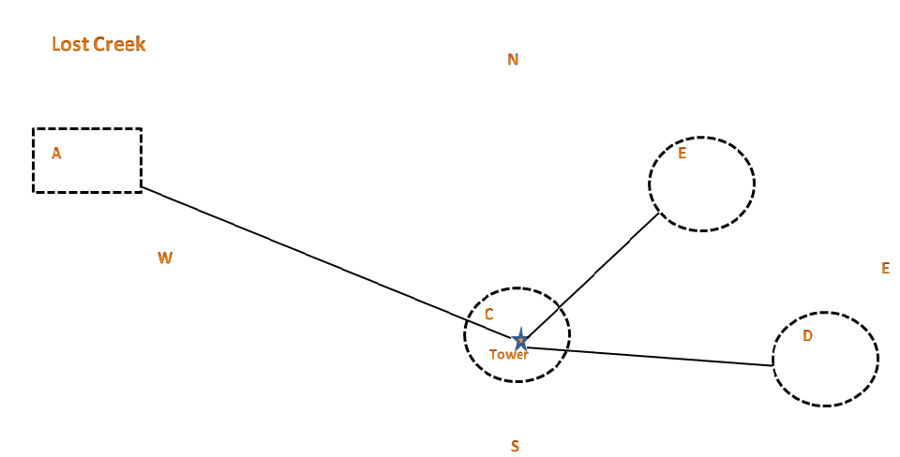

GPS Coordinates:

C (Tower): N46°08.274’  W89° 97.855’

A (Forest): N46°04.971’  W89° 59.069’

D (Flowing): N46°08.315’  W89°97.7095’

E (Stagnant): N46°08.317’  W89°97.744’