US-Syv: Sylvania Wilderness Area Plot Diagrams, Explanations
There are two hectare plots at Sylvania in the upper peninsula of Michigan, USA. The first surrounds the eddy covariance tower and the dominant tree species is sugar maple, thus the plot is referred to as either the tower plot or the sugar maple plot. The other plot is on a nearby peninsula that is dominated by hemlock pine trees and is referred to as the hemlock plot. All variables for these two plots are measured and calculated separately. Radii for the subplot varies by measurement (see protocol).
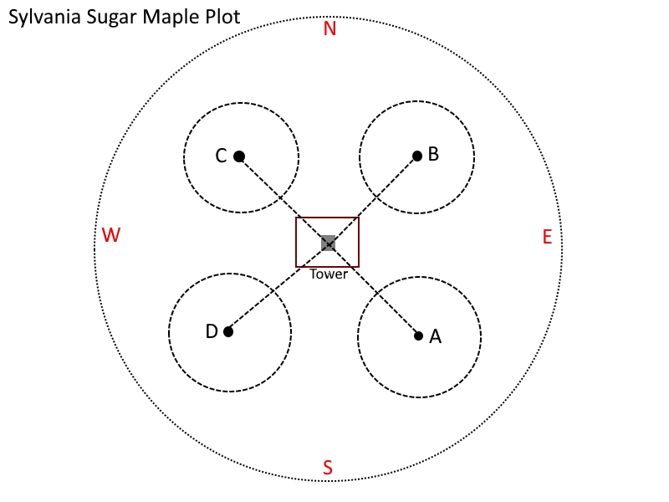
GPS Coordinates:
Tower: N46º14.534’ W89º20.758’
A: N46º14.524’ W89º20.740’
B: N46º14.537’ W89º20.752’
C: N46º14.522’ W89º20.761’
D: N46º14.515’ W89º20.762’
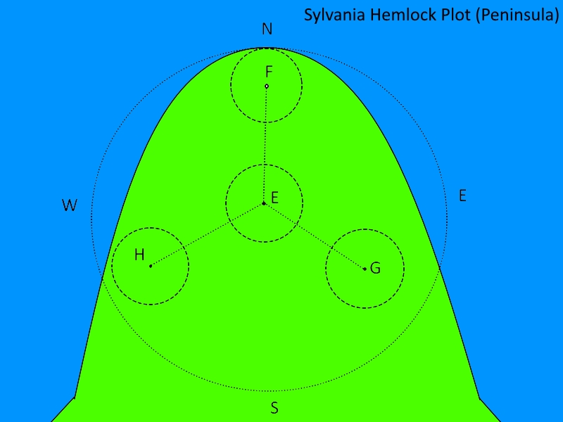
GPS Coordinates:
E: N46º14.595’ W89º20.668’
F: N46º14.611’ W89º20.690’
G: N46º14.582’ W89º20.660’
H: N46º14.581’ W89º20.678’

