Cheyenne: read through proposals : Application Deadline Mar 23

A. Project Information

Project title: CHEESEHEAD19

Title of NSF award: Chequamegon Heterogeneous Ecosystem Energy-balance Study Enabled by a High-density Extensive Array of Detectors

NSF award number: 1822420

Project lead: Ankur Desai, University of Wisconsin – Madison , Department of Atmospheric and Oceanic Sciences

Submission date: March 23, 2020

B. Overview of Project

Prompt:

• A summary of the science question and computational plan.

• The relationship of the proposed work to atmospheric and closely related sciences.

• The explicit linkage between the NSF award and the computational experiments being proposed. This is especially important if the published NSF award abstract does not clearly describe the computational component of the work funded

(Taken from the NSF project [page](https://nsf.gov/awardsearch/showAward?AWD_ID=1822420&HistoricalAwards=false))

The living biosphere interacts with atmospheric processes at a multitude of scales. Understanding these processes requires integration of multiple observations for comparison to theories embedded in atmospheric models. But, all observations mismatch the scale of all models. Therefore, spatial and temporal scaling of surface fluxes is fundamental to how we evaluate theories on what happens within the sub-grid of atmospheric models and how those feed back onto larger scale dynamics. The Chequamegon Heterogeneous Ecosystem Energy-balance Study Enabled by a High-density Extensive Array of Detectors (CHEESEHEAD) is an intensive field-campaign designed specifically to address long-standing puzzles regarding the role of atmospheric boundary-layer responses to scales of spatial heterogeneity in surface-atmosphere heat and water exchanges.

The high-density observing network is coupled to large eddy simulation (LES) and machine-learning scaling-experiments to better understand sub-mesoscale responses and improve numerical weather and climate prediction formulations of sub-grid processes. This project will advance spatiotemporal scaling methods for heterogeneous land surface properties and fluxes and theories on the scales at which the lower atmosphere responds to surface heterogeneity. CHEESEHEAD aims to provide a level of observation density and instrumentation reliability never previously achieved to test and develop hypotheses on spatial heterogeneity and atmosphere feedbacks.

The experiment generates knowledge that advances the science of surface flux measurement and modeling, relevant to many scientific applications such as numerical weather prediction, climate change, energy resources, and computational fluid dynamics. The research will train next generation land-atmosphere graduate and undergraduate students. Field support outreach and teacher training is included via middle, high school, and undergraduate student involvement at nearby schools and colleges in coordination with UCAR's (University Corporation for Atmospheric Research) GLOBE program, Northland College, and local school districts. The database of observations and models will be made immediately available to the community and public for general use for further scientific advancement

C. Science Objectives :

Prompt:

The science objectives should be described briefly. This section should give sufficient information for understanding the computational plan in section D; it is not necessary to justify the science objectives as they must have already passed NSF review.

Advice for preparing your request. "Brief" is the operative word for your science description. The panel is not judging your science, only trying to understand how and if your computational experiments (described in Section D) will help you find answers to your science questions. This section should be between 1/2 and 1 page long.

Cheesehead Experiment goals:

The goal of CHEESEHEAD is to intensively sample and simulate the surface and

boundary layer within the heterogeneous subgrid of a single “grid” cell of a weather or climate model (i.e., 10x10 km) to improve representation of surface energy balance and atmospheric response to surface heterogeneity in these models. Our analysis is based on mapping variation in surface energy balance, detecting atmospheric response to surface energy balance variability, and evaluating models for scaling and simulating these processes with statistical models and LES over a three months from mid-summer to early fall. During this time, we expect the surface energy balance to transition from more uniform transpiration (latent heat flux) dominated landscape to a patchy sensible heat flux dominated landscape. (Figure?)

Using this experiment, we plan to:

1. Investigate causes of energy balance closure over heterogeneous ecosystems    and the role of local lower atmospheric circulations therein
2. Study the role of such circulations in the representativeness of single or multi-site surface energy fluxes and ecological measurements when compared with the grid average
   1. Apply machine learning scaling experiments alongside the LES experiments to simulate sub-mesoscale processes
   2. Scale surface fluxes across the heterogeneous domain
   3. Improving model-data comparison

D. Computational Experiments and Resource Requirements

D1. Numerical Approach

**Model setup**

The Parallelized LES Model PALM (Maronga et al. 2015, 2000) will be used for numerical simulations. PALM solves the non-hydrostatic incompressible Boussinesq equations. For the subgrid model the kinetic energy scheme of Deardorff (1980) is used. The advection terms were discretized using a fifth-order scheme (Wicker and Skamarock 2002), and a third-order Runge Kutta scheme by Williamson (1980) is used for the time integration.

We already did pre-IOP runs using PALM. (elaborate a bit more)

To accurately simulate sub grid scale processes as observed during the IOPs of the field experiment as realistic as possible, we will apply a land surface model with coupled soil, radiation and a plant canopy model with the topography for the domain. This offers a detailed analysis of the physical processes involved and ensures worthwhile comparisons with observations such as computing radiation footprints for the surface energy balance, including direct interaction to the synoptic and radiative forcings, etc..

The inbuilt Land Surface Module in PALM consists of a multi layer soil model, that predicts soil temperature and moisture content, and a solver for the energy balance, predicting the temperature of the surface or the skin layer (depending on land use classification). The implementation is based on the ECMWF-IFS land surface parametrization (H-TESSEL) and its adaptation in the DALES model (Heus et al. 2010).

The LSM will be setup for each IOP test case, with land use classes and soil and vegetation data as measured/observed during the field experiment. Since the modeling domain is forested, the observed tree tops will be resolved using the inbuilt Plant Canopy Model in PALM. The canopy is modeled as a porous viscous medium that removes momentum from the flow (Shaw & Schumann, 1992; Watanabe, 2004), and acts as source/sink for heat, humidity, or passive scalar. The forest canopy will be initialized using observed parameters from canopy LiDAR measurements (Christian Andresen, Forest canopy structure characterization using high-density UAV LiDAR AGU 2019) and field observations.

Setting up coupled LSM, PCM runs will help investigate surface atmospheric feedbacks such as self-reinforcement of mes-scale circulations over the heterogeneous study domain (Luise Wanner Optimizing Large-eddy Simulations for Investigating the Energy-balance Closure Problem at Typical Eddy-covariance Measurement Heights AGU 2019)

This will be setup using a static driver for each of the IOPs, a netcdf file characterizing the vegetation, plant canopy Model and domain topography (DEM)

D2. Computational Experiments

We propose to run LES case studies for 48 hour simulations for each IOP period using PALM. The whole diurnal cycles will be included with 8 ensemble runs for each. So, 3 case studies of two days with 8 ensemble runs for each.

Boundary conditions & Forcings

To have realistic synoptic forcings data at the model lateral boundaries, PALM can be nested within a grid cell of WRF. The synoptic forcing data (temperature-, humidity and momentum advection, mean radiative forcing) will be derived this from WRF output.

Since mesoscale models like WRF do not have resolved scale turbulent fluxes, we will need **adjustment zones** were turbulence need to develop at the inflow boundary so that we would have realistic turbulence within the domain of interest and the nesting approach does not affect the analysis anyway.  This approach works well with one way nesting, where the child gets the boundary conditions from parent with no feedback loop . A rough estimate of the required fetch length is about 3-5 times the CBL depth (of the order of 1 to 2 km). Pre IOP runs were done with 30 km x 30 km domain. Forced by ERF surface flux maps, to optimize measurement strategies. So, for  these realistic runs, domain size of 40 x 40 km and a coarse resolution ( 50 m grid spacing) and having finer inner child domains (with higher grid resolution)

Alternatives and notes not sure about including in the final version:

* Profile data from sonde measurements and LiDAR measurements: easier to implement, less computationally expensive
* Depending on the processes we are looking for we need to run sensitivity tests for the grid spacing.
* Also we need to check the horizontal extension of the outermost model domain. If we nest the PALM domain into WRF,
  + Alternatively we can apply **cyclic boundary conditions** as we did for the LITFASS simulations, however, depending on wind speed also large buffer zones will be required to get rid-off effects related to **unrealistic upwind surface heterogeneity**.

I would suggest to blanketly estimate the computational demand for these sensitivity tests to 20% of the final simulation.

Science use cases:

Parametric heterogeneity correction. Realistic virtual tower measurements to investigate the energy balance non closure problem by simulating the tower level turbulent characteristics as observed during the field campaign. The model data will be analyzed to come up with a parametric correction for heterogeneity effects. A control volume analysis of the model output can help quantify the advection and horizontal flux divergence.

Introducing virtual towers into the domain lets us compare model outputs with real observations for the same conditions and ask interesting questions and do interesting comparisons. For eg. resolving the plant canopy lets us resolve inertial sublayer impact on the data using the LES data.

The virtual towers will have multiple measurement heights at 20, 50,100 and 200 m to study how EB closure and turbulent characteristics are resolved.

Analysis of model data, not including: Apply parametric heterogeneity correction to Ches towers and compare to ERF flux field in 30-min footprints

* bring the various approaches together
* proof of internal consistency

To diagnose secondary circulations vis-à-vis surface heterogeneity scales and quantify the scale transport associated with them we will be outputting 3 dimensional wind, temperature and water vapor data. This can help us study the dynamical factors at play behind the physical processes by looking at vorticity budgets etc.

Virtual flight will be setup during the run to mimic the actual IOP measurements, to sample the turbulent signals of wind, temperature and specific humidity. Flux footprint maps are being prepared from the actual flight observations; the LES run outputs will also be analyzed likewise and compared alongside these real world measurements. The comparisons, alongwith spatio-temporally resolved LES outputs can help us investigate the role of landscape scale low frequency motions in surface-atmosphere exchange in line with our science objectives.

We also plan to setup virtual LiDAR measurements to replicate the actual LiDAR measurements during the measurement campaign.

We plan to set up a lagrangian particle model to compare with projections for tower and aircraft data using the ERF machine learning approach. The same approach ( passive tracers using lagrangian particles) will also be used to investigate the effects of surface heterogeneity on boundary-layer top entrainment and how this in turn affects tower measurements (passive tracer approach)

Not sure if we should include this as an additional experiment.

To Create time-space continuous LST, LSM, vertical profiles of humidity and temperature?

Ankur: downscaling via data-fusion. Come up with a CHEESEHEAD reanalysis using

LES . Possible/alternative approach to fuse data + prescribed processes?

The data product can inform :

ERF driver

soil heat flux

biomass storage

D3. Code Performance

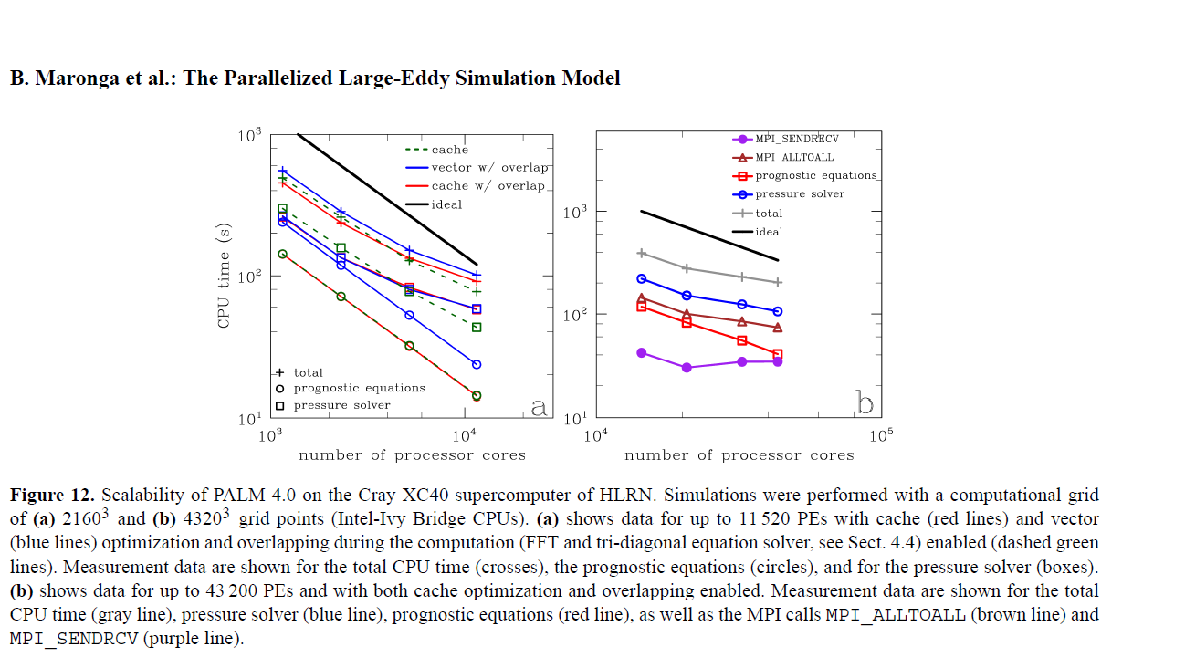

D4. Resource Requirements

Core-hours: Using timing tests

|  |  |  |  |  |  |  |  |  |  |
| --- | --- | --- | --- | --- | --- | --- | --- | --- | --- |
|  |  |  | System Size | |  |  |  |  |  |
| Study | Simulation Count | Sim Days | Parent | Child | Time Steps | Core hours per simulation | Total Core hours | Archival Space | Total Archival Space |
| IOP 01 | 8 | 2 |  |  |  |  |  |  |  |
| IOP 02 | 8 | 2 |  |  |  |  |  |  |  |
| IOP 03 | 8 | 2 |  |  |  |  |  |  |  |

HPSS Archive:

Project File Space:

Data Analysis and Visualization (Casper): 2 users, Luise and Sreenath: 10,000 core-hours

Multi-Year Plan: 'We will complete the proposed simulations and data analysis by Sep 2016.'

E. Data Management Plan

F. Accomplishment Report

Pre IOP run details

Numerical experiment design paper